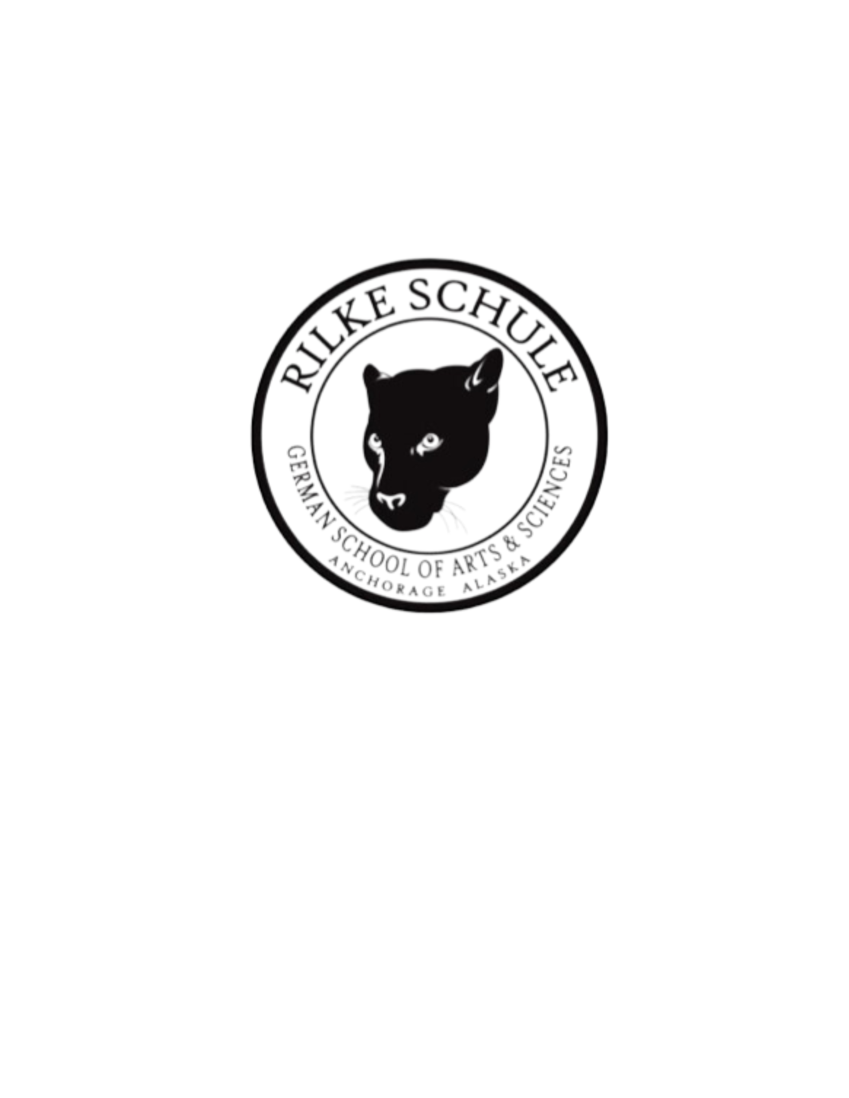

Fashing Auction Fundraiser 2025

Item Donation Form

Rilke Schule German Immersion School

1846 E 64th Ave

Anchorage, AK 99507

**Donor Information**

| Donor Name/Organization: |  |
| --- | --- |
| Contact Name: |  |
| Address: |  |
| City, State, Zip: |  |
| Phone: |  |
| Email: |  |

**Item Information**

| Item/Gift Certificate | Description | Fair Market Value |
| --- | --- | --- |
|  |  |  |
|  |  |  |
|  |  |  |

**Item Donation**

___ I will send or drop off my donation to the address on this form before January 10, 2025.

___ I am located in the Anchorage area and would like my donation to be picked up.

The item is located at _______________________________________________

And will be ready for pick-up (date/time) ________________________________

Donor Signature, Date